How to run PHP application and create a data base

Firstly install XAMPP in your PC/ Laptop then once it is done installing start the following modules below

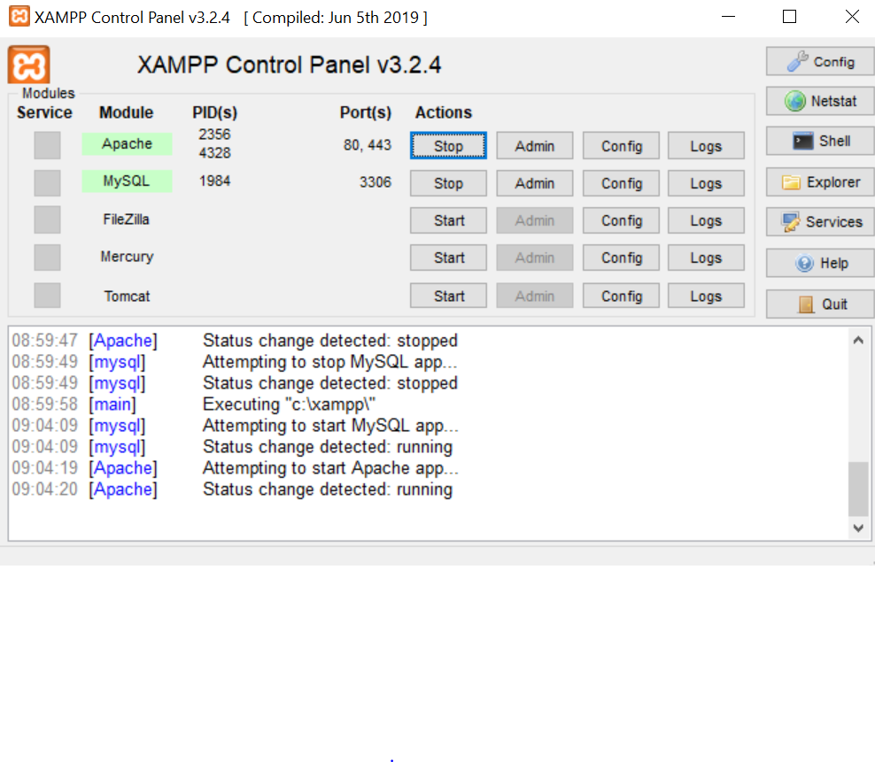

**3.0 RUN YOUR FIRST PHP SCRIPT**

The following is an example about how to run a PHP script. What this program does is show a "Hello World!" text on the screen or webpage.

**3.1 Go to XAMPP server directory**

I'm using Windows, so copy the .php from the Employee-Management-system project and then past them at server directory is "C:\xampp\htdocs\".

**3.2 Open New Tab**

Run it by opening a new tab in your browser

**3.3 Load hello.php**

On you browser window, type http://localhost/login.php

**3.6 Output**

You should see the following output.

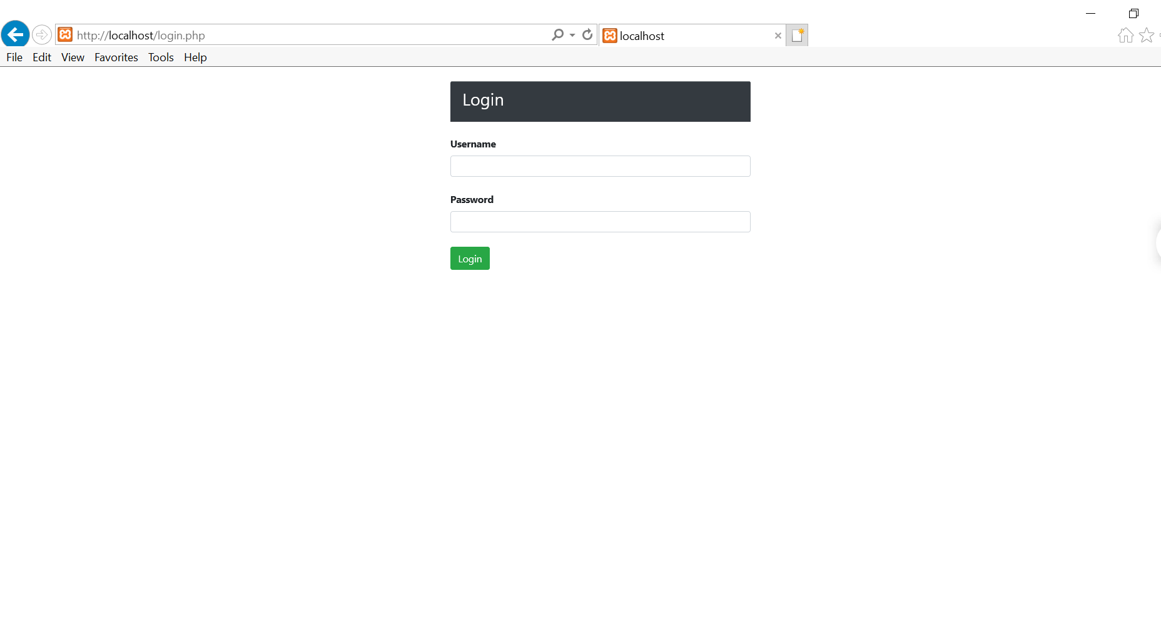

After loging in as an **Admin**

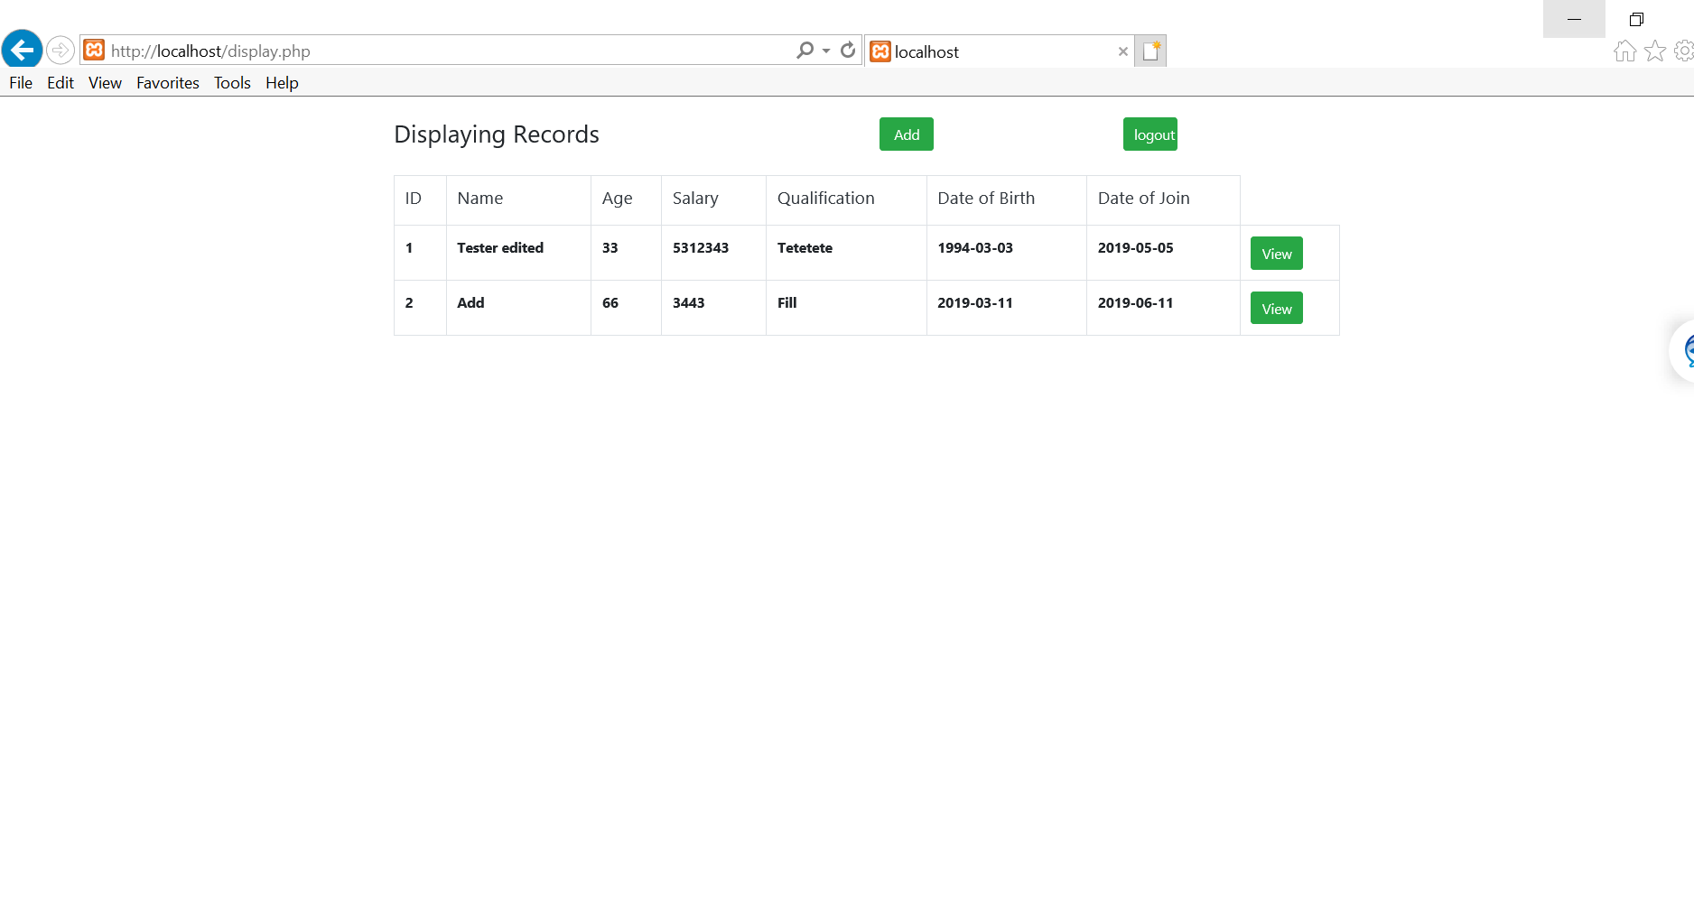

Clicking add button

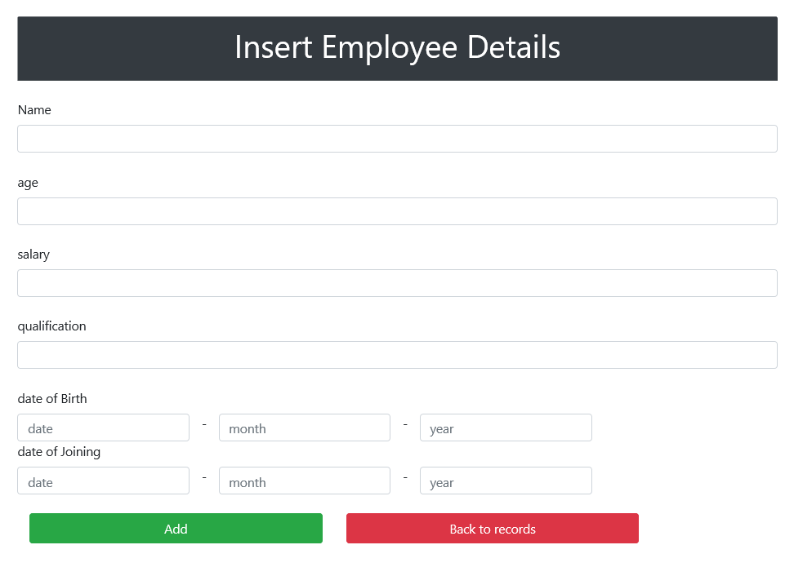

Clicking view button

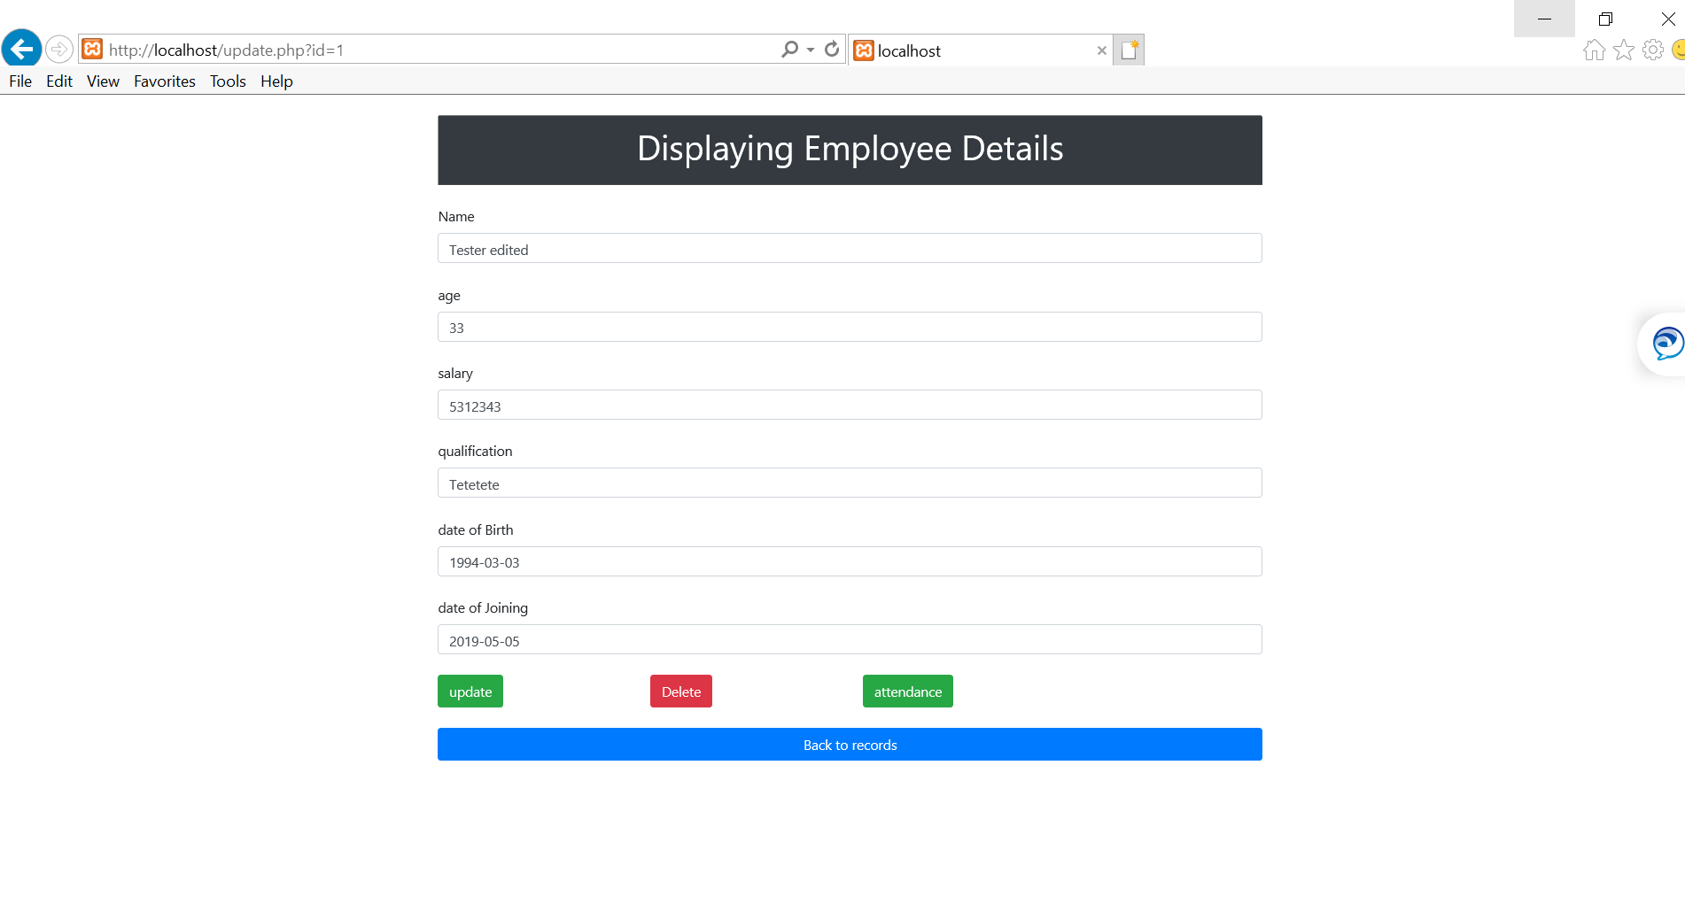

Clicking attendance button

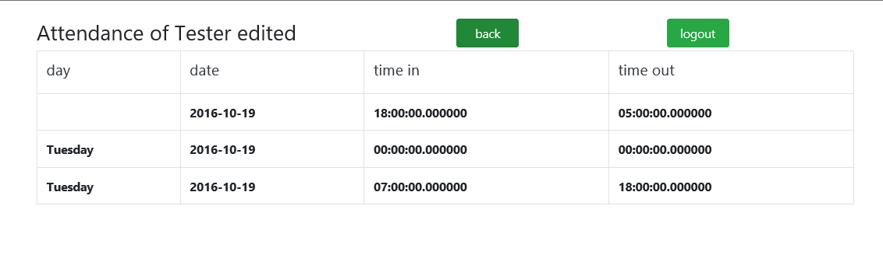

* Delete and update button will execute sql comands

Loggin in as a User/employee

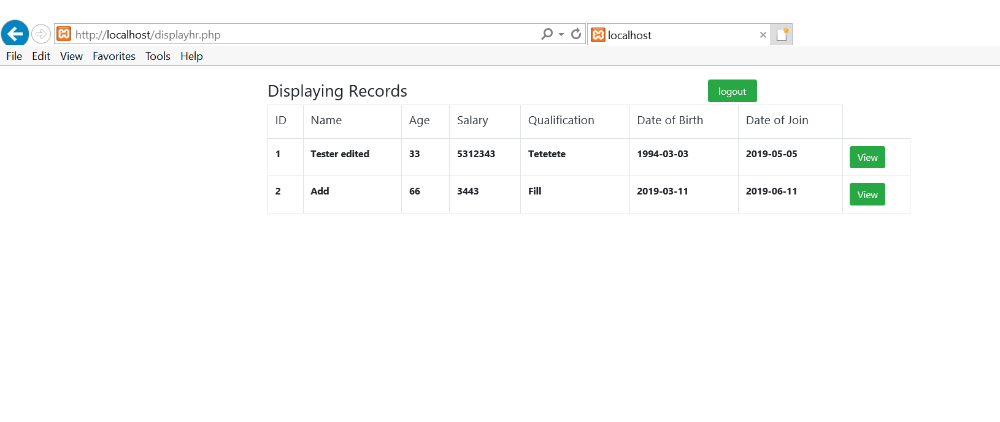

Clicking view button

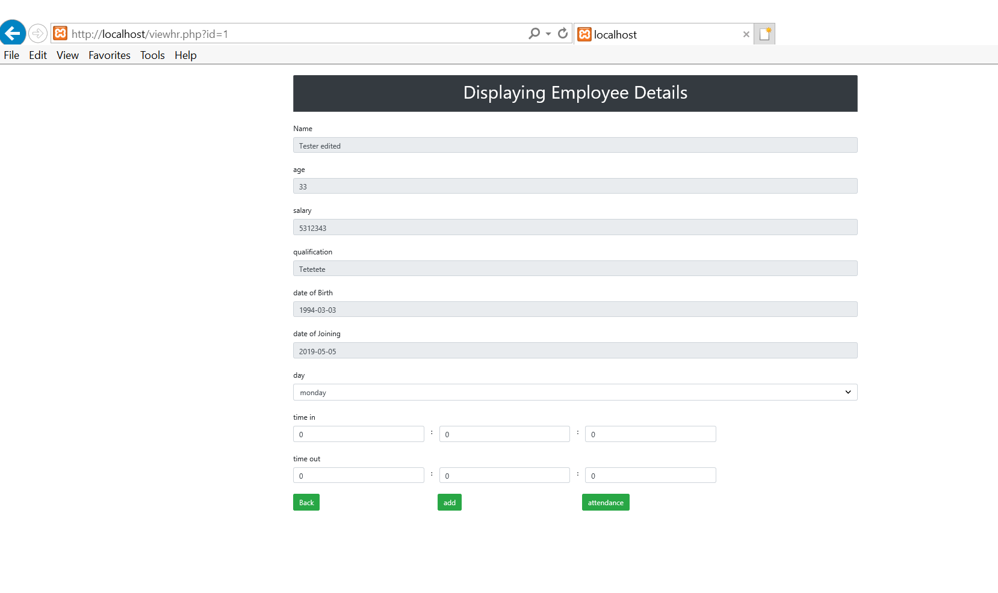

## 4.0 MANAGE MYSQL WITH PHPMYADMIN

[MySQL](https://www.mysql.com/) is an open-source [relational database management system](https://en.wikipedia.org/wiki/Relational_database_management_system) (RDBMS). MySQL is a popular choice of [database](https://en.wikipedia.org/wiki/Database) for use in web applications.

[phpMyAdmin](https://www.phpmyadmin.net/) is a free and open source tool written in PHP intended to handle the administration of MySQL with the use of a web browser. In the following examples, we will see how easy we can handle MySQL with PhpMyAdmin.

### 4.1 Create a Database

1. Go to [**http://localhost/phpmyadmin/**](http://localhost/phpmyadmin/)
2. Click the "**New**" link on the upper left corner (under recent tables)
3. Fill out the "**Database Name**" field with "**test**".
4. Click the "**Create**" button

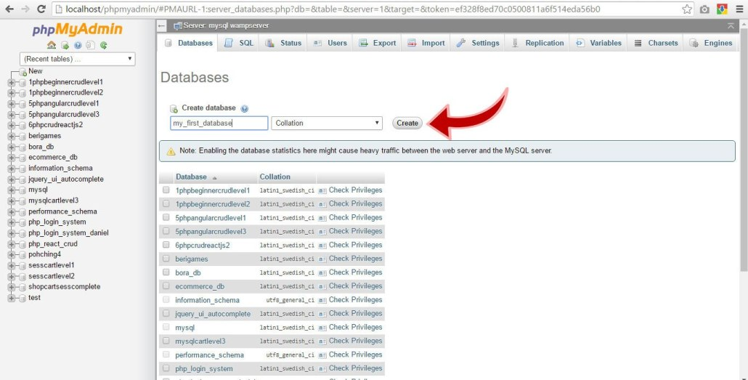

**4.2 Create a Table**

1. Click "**test**" on the left side of the screen
2. On the "Create Table" section, fill out the *Name* with "**employee**" and *Number of Columns*with "**7**"
3. Click "**Go**" button

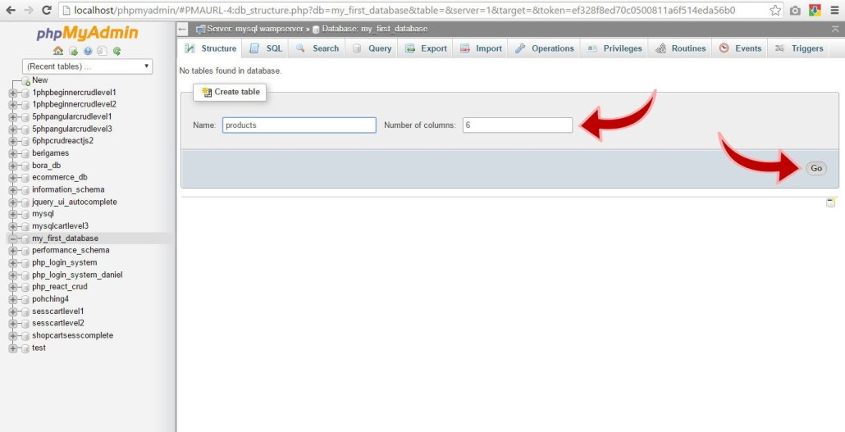

Create The following Tables

employee

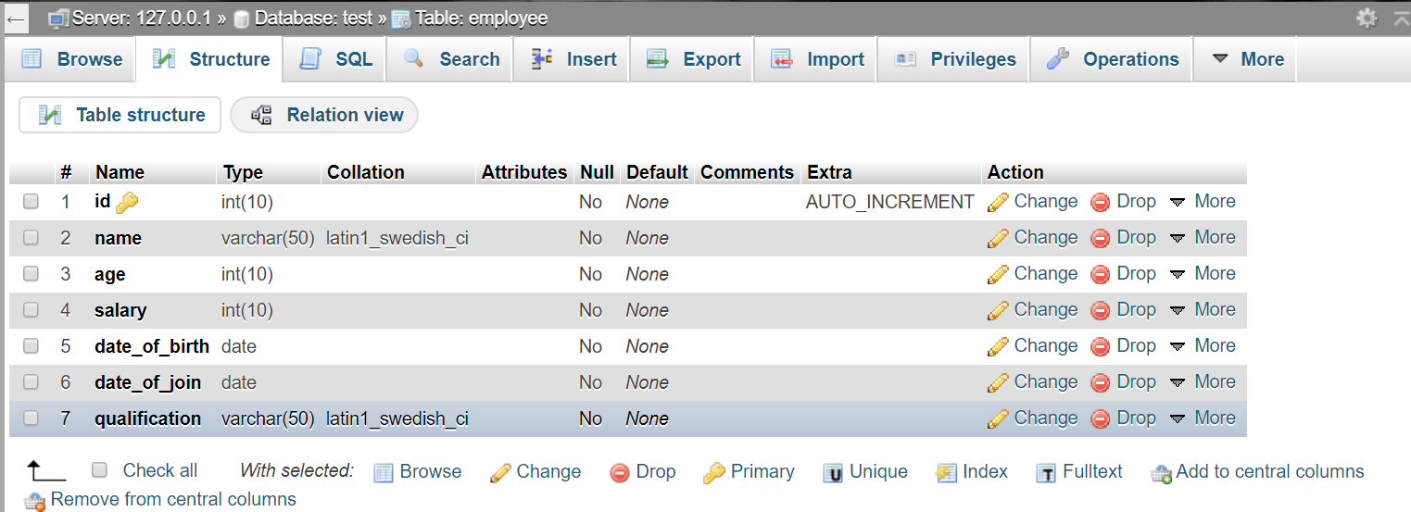

login

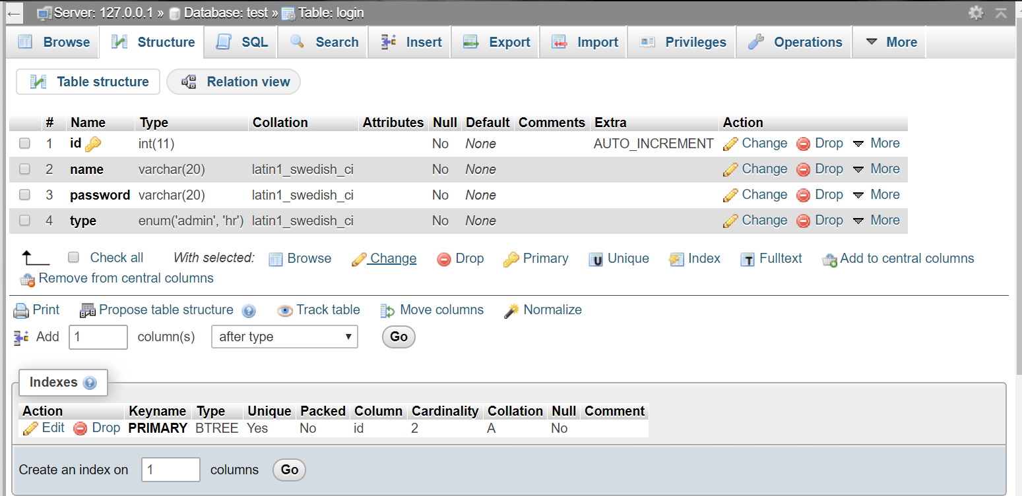

time

